Social Science Grade 6
Revision question Paper - 3
I. Tick the correct answer. 5M
- Lagoons are found in
a. Sikkim b. Kerala
C. Gangetic plains d. None of these
2. The two epics, Ramayana and Mahabharata were produced in the
a. Early Vedic period b. Later Vedic period
b. None of this d. Before early Vedic period
3. The Persian Empire was founded by
a. Cyrus the great b. Darius I.
c. Xerxes d. Chandra Gupta
4. Ashoka encouraged his subjects to be
a. strict with the slaves b. kind and charitable to all
c. Intolerant towards other religions d. None of these
5. Two handled jugs used by Romans to store wine or other liquids are known as
a. Cellars b. Amphorae
c. kegs d. None of these

II. Answer the following

- Why do democratic countries hold elections at regular intervals? How are elections useful? 2M
- What do you understand by the term ‘mango showers’? 2M
- Explain the types of Occupation. 2M
- Name the three ranges of the Himalayas. 3M
- Differentiate between western coastal plains and eastern coastal plains. 5M

- Read the passage and answer the questions. 4M
In ancient times, the area along these rivers to the south of the Ganga was known as Magadha now lying in the state of Bihar. Its rulers were very powerful, and set up a large kingdom. Throughout, people travelled from one part of the subcontinent to another. The hills and high mountains including the Himalayas, deserts, rivers and seas made journeys dangerous at times, but never impossible. So, men and women moved in search of livelihood, as also to escape from natural disasters like floods or droughts. Sometimes men marched in armies, conquering others lands.
- The area along these rivers to the south of the Ganga was known as?
- Why did people travel from one part of the subcontinent to another?
- What all things made journey difficult at time?
- Why did men march in armies from one place to another?

- Look at the picture carefully and answer the given questions. 2M
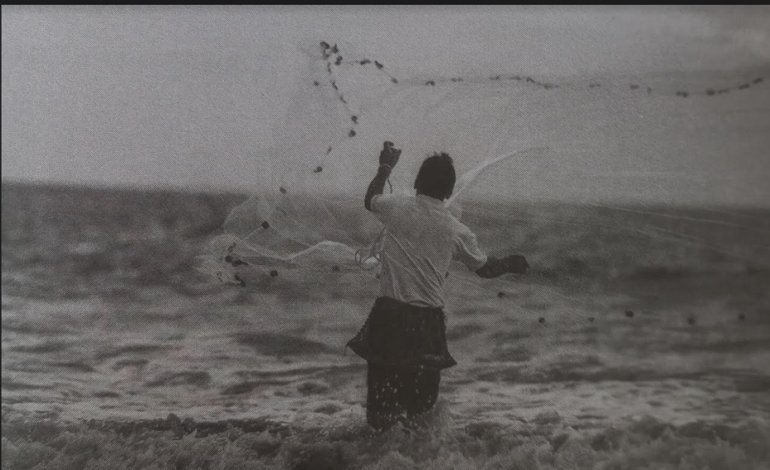
- Which type of occupation is shown in the picture?
- Can you list a few states of India where this occupation is widely practiced?

